                 USN : 2GI19CS175                                              Student Name : Venkatesh G D

**Title of the Experiment (GUI – [Graphical User Interface] )**

**Experiment  No.**  ___10_______                                                                          **Date :** _24/12/20______

**Problem Statement :**

Design and develop a GUI application as shown below. Assume the two numbers to be integers. The application must check for invalid division condition and throw an appropriate exception.

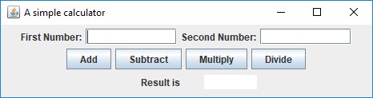

**Objectives of the Experiment :**

1. Learn to design and develop GUI (Graphical User Interface).
2. Understand the use of GUI in a real-life application.
3. Learn to Display the result in a readable/proper format .

**Program Source Code :**

package tw10;

import javax.swing.JOptionPane;

public class Calculator extends javax.swing.JFrame {

/**

* Creates new form Calculator

*/

public Calculator() {

initComponents();

}

/**

* This method is called from within the constructor to initialize the form.

* WARNING: Do NOT modify this code. The content of this method is always

* regenerated by the Form Editor.

*/

@SuppressWarnings("unchecked")

// <editor-fold defaultstate="collapsed" desc="Generated Code">//GEN-BEGIN:initComponents

private void initComponents() {

jLabel1 = new javax.swing.JLabel();

t1 = new javax.swing.JTextField();

jLabel2 = new javax.swing.JLabel();

t2 = new javax.swing.JTextField();

jButton1 = new javax.swing.JButton();

jButton2 = new javax.swing.JButton();

jButton3 = new javax.swing.JButton();

jButton4 = new javax.swing.JButton();

t3 = new javax.swing.JTextField();

jLabel3 = new javax.swing.JLabel();

setDefaultCloseOperation(javax.swing.WindowConstants.EXIT_ON_CLOSE);

setTitle("A simple calculator");

jLabel1.setText("First Number");

jLabel2.setText("Second Number");

jButton1.setText("Add");

jButton1.addActionListener(new java.awt.event.ActionListener() {

public void actionPerformed(java.awt.event.ActionEvent evt) {

jButton1ActionPerformed(evt);

}

});

jButton2.setText("Subtract");

jButton2.addActionListener(new java.awt.event.ActionListener() {

public void actionPerformed(java.awt.event.ActionEvent evt) {

jButton2ActionPerformed(evt);

}

});

jButton3.setText("Multiply");

jButton3.addActionListener(new java.awt.event.ActionListener() {

public void actionPerformed(java.awt.event.ActionEvent evt) {

jButton3ActionPerformed(evt);

}

});

jButton4.setText("Divide");

jButton4.addActionListener(new java.awt.event.ActionListener() {

public void actionPerformed(java.awt.event.ActionEvent evt) {

jButton4ActionPerformed(evt);

}

});

jLabel3.setText("Result is ");

javax.swing.GroupLayout layout = new javax.swing.GroupLayout(getContentPane());

getContentPane().setLayout(layout);

layout.setHorizontalGroup(

layout.createParallelGroup(javax.swing.GroupLayout.Alignment.LEADING)

.addGroup(layout.createSequentialGroup()

.addGap(29, 29, 29)

.addGroup(layout.createParallelGroup(javax.swing.GroupLayout.Alignment.TRAILING)

.addGroup(javax.swing.GroupLayout.Alignment.LEADING, layout.createSequentialGroup()

.addComponent(jButton1)

.addGap(42, 42, 42)

.addComponent(jButton2)

.addGap(40, 40, 40)

.addComponent(jButton3)

.addGap(73, 73, 73)

.addComponent(jButton4)

.addContainerGap())

.addGroup(layout.createSequentialGroup()

.addGap(0, 0, Short.MAX_VALUE)

.addGroup(layout.createParallelGroup(javax.swing.GroupLayout.Alignment.TRAILING)

.addGroup(layout.createSequentialGroup()

.addComponent(jLabel1)

.addGap(18, 18, 18)

.addComponent(t1, javax.swing.GroupLayout.PREFERRED_SIZE, 104, javax.swing.GroupLayout.PREFERRED_SIZE))

.addComponent(jLabel3))

.addGap(57, 57, 57)

.addGroup(layout.createParallelGroup(javax.swing.GroupLayout.Alignment.LEADING)

.addGroup(javax.swing.GroupLayout.Alignment.TRAILING, layout.createSequentialGroup()

.addComponent(jLabel2)

.addGap(27, 27, 27)

.addComponent(t2, javax.swing.GroupLayout.PREFERRED_SIZE, 108, javax.swing.GroupLayout.PREFERRED_SIZE)

.addGap(57, 57, 57))

.addGroup(javax.swing.GroupLayout.Alignment.TRAILING, layout.createSequentialGroup()

.addComponent(t3, javax.swing.GroupLayout.PREFERRED_SIZE, 156, javax.swing.GroupLayout.PREFERRED_SIZE)

.addGap(179, 179, 179))))))

);

layout.setVerticalGroup(

layout.createParallelGroup(javax.swing.GroupLayout.Alignment.LEADING)

.addGroup(layout.createSequentialGroup()

.addGap(90, 90, 90)

.addGroup(layout.createParallelGroup(javax.swing.GroupLayout.Alignment.BASELINE)

.addComponent(t2, javax.swing.GroupLayout.PREFERRED_SIZE, javax.swing.GroupLayout.DEFAULT_SIZE, javax.swing.GroupLayout.PREFERRED_SIZE)

.addComponent(jLabel2)

.addComponent(jLabel1)

.addComponent(t1, javax.swing.GroupLayout.PREFERRED_SIZE, javax.swing.GroupLayout.DEFAULT_SIZE, javax.swing.GroupLayout.PREFERRED_SIZE))

.addGap(32, 32, 32)

.addGroup(layout.createParallelGroup(javax.swing.GroupLayout.Alignment.BASELINE)

.addComponent(jButton2)

.addComponent(jButton3)

.addComponent(jButton4)

.addComponent(jButton1))

.addGap(62, 62, 62)

.addGroup(layout.createParallelGroup(javax.swing.GroupLayout.Alignment.BASELINE)

.addComponent(jLabel3)

.addComponent(t3, javax.swing.GroupLayout.PREFERRED_SIZE, javax.swing.GroupLayout.DEFAULT_SIZE, javax.swing.GroupLayout.PREFERRED_SIZE))

.addContainerGap(97, Short.MAX_VALUE))

);

pack();

}// </editor-fold>//GEN-END:initComponents

private void jButton1ActionPerformed(java.awt.event.ActionEvent evt) {//GEN-FIRST:event_jButton1ActionPerformed

t3.setText(""+(Integer.parseInt(t1.getText())+Integer.parseInt(t2.getText())));

}//GEN-LAST:event_jButton1ActionPerformed

private void jButton2ActionPerformed(java.awt.event.ActionEvent evt) {//GEN-FIRST:event_jButton2ActionPerformed

t3.setText(""+(Integer.parseInt(t1.getText())-Integer.parseInt(t2.getText())));

}//GEN-LAST:event_jButton2ActionPerformed

private void jButton3ActionPerformed(java.awt.event.ActionEvent evt) {//GEN-FIRST:event_jButton3ActionPerformed

t3.setText(""+Integer.parseInt(t1.getText())*Integer.parseInt(t2.getText()));

}//GEN-LAST:event_jButton3ActionPerformed

private void jButton4ActionPerformed(java.awt.event.ActionEvent evt) {//GEN-FIRST:event_jButton4ActionPerformed

int a = Integer.parseInt(t1.getText());

int b = Integer.parseInt(t2.getText());

try{

float res = a /(float)b;

t3.setText("" + String.format("%.2f",res));

}

catch(ArithmeticException e)

{

JOptionPane.showMessageDialog(null, "invalid arithmetic operation!");

}

}//GEN-LAST:event_jButton4ActionPerformed

/**

* @param args the command line arguments

*/

public static void main(String args[]) {

/* Set the Nimbus look and feel */

//<editor-fold defaultstate="collapsed" desc=" Look and feel setting code (optional) ">

/* If Nimbus (introduced in Java SE 6) is not available, stay with the default look and feel.

* For details see http://download.oracle.com/javase/tutorial/uiswing/lookandfeel/plaf.html

*/

try {

for (javax.swing.UIManager.LookAndFeelInfo info : javax.swing.UIManager.getInstalledLookAndFeels()) {

if ("Nimbus".equals(info.getName())) {

javax.swing.UIManager.setLookAndFeel(info.getClassName());

break;

}

}

}

catch (ClassNotFoundException ex) {

java.util.logging.Logger.getLogger(Calculator.class.getName()).log(java.util.logging.Level.SEVERE, null, ex);

}

catch (InstantiationException ex) {

java.util.logging.Logger.getLogger(Calculator.class.getName()).log(java.util.logging.Level.SEVERE, null, ex);

} catch (IllegalAccessException ex) {

java.util.logging.Logger.getLogger(Calculator.class.getName()).log(java.util.logging.Level.SEVERE, null, ex);

} catch (javax.swing.UnsupportedLookAndFeelException ex) {

java.util.logging.Logger.getLogger(Calculator.class.getName()).log(java.util.logging.Level.SEVERE, null, ex);

}

//</editor-fold>

/* Create and display the form */

java.awt.EventQueue.invokeLater(new Runnable() {

public void run() {

new Calculator().setVisible(true);

}

});

}

// Variables declaration - do not modify//GEN-BEGIN:variables

private javax.swing.JButton jButton1;

private javax.swing.JButton jButton2;

private javax.swing.JButton jButton3;

private javax.swing.JButton jButton4;

private javax.swing.JLabel jLabel1;

private javax.swing.JLabel jLabel2;

private javax.swing.JLabel jLabel3;

private javax.swing.JTextField t1;

private javax.swing.JTextField t2;

private javax.swing.JTextField t3;

// End of variables declaration//GEN-END:variables

}

**Output :**

Case 1:

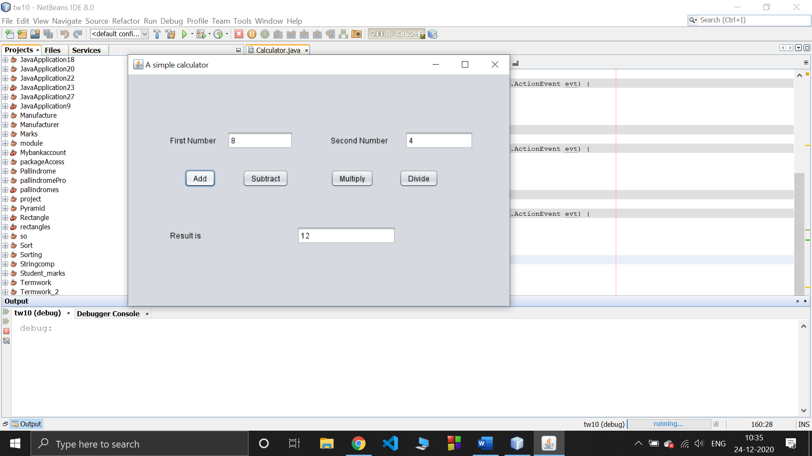

Case 2:

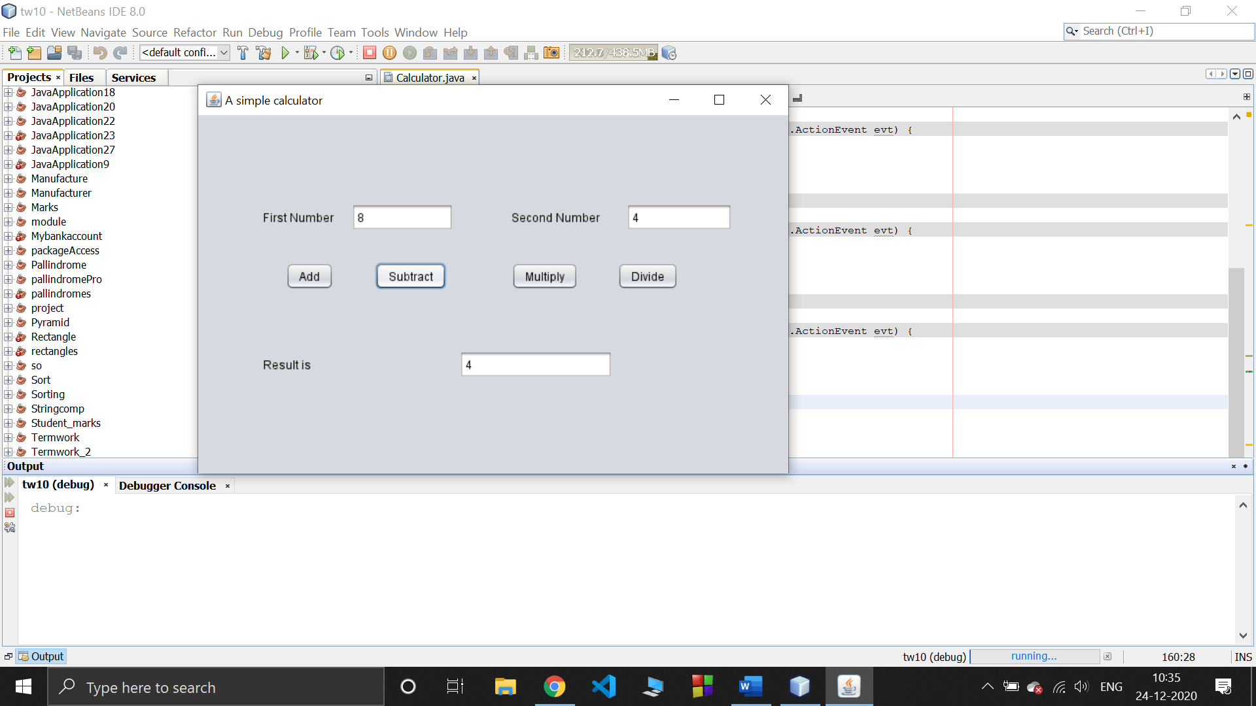

Case 3:

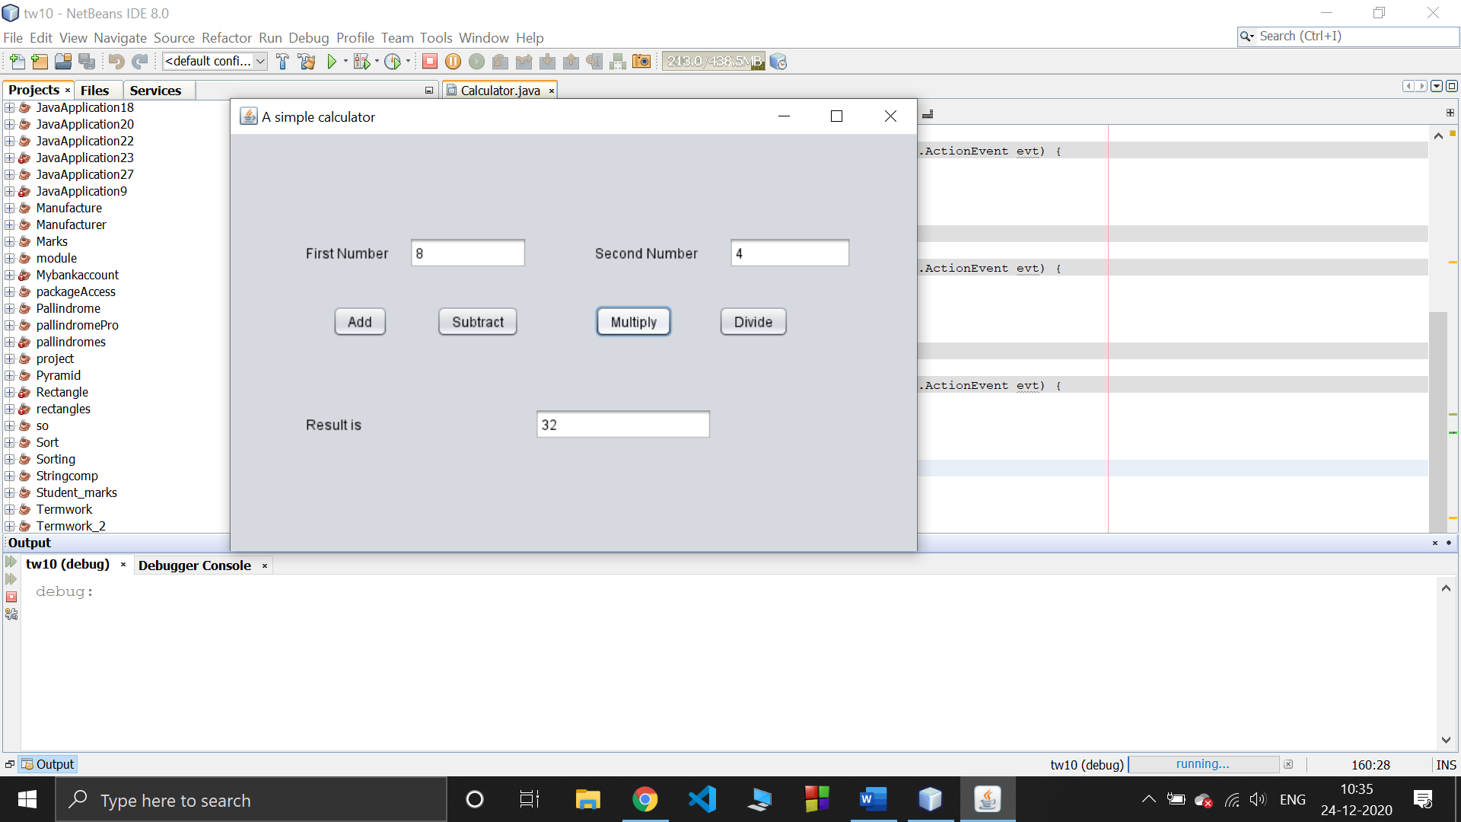

Case 4:

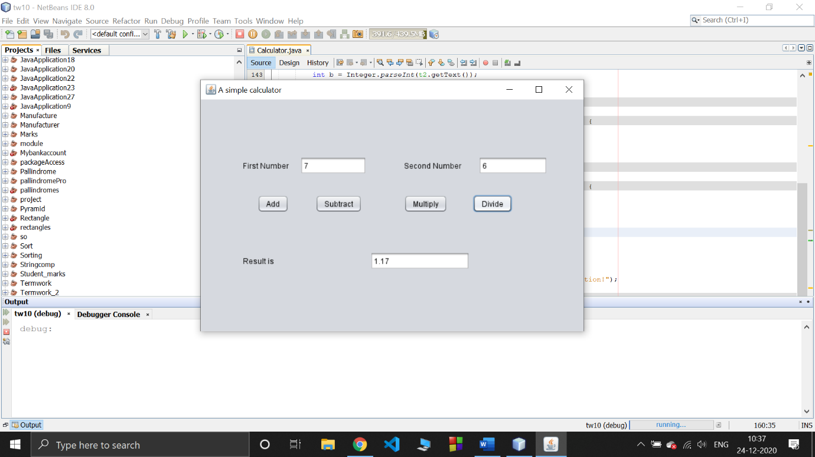

Case 5:

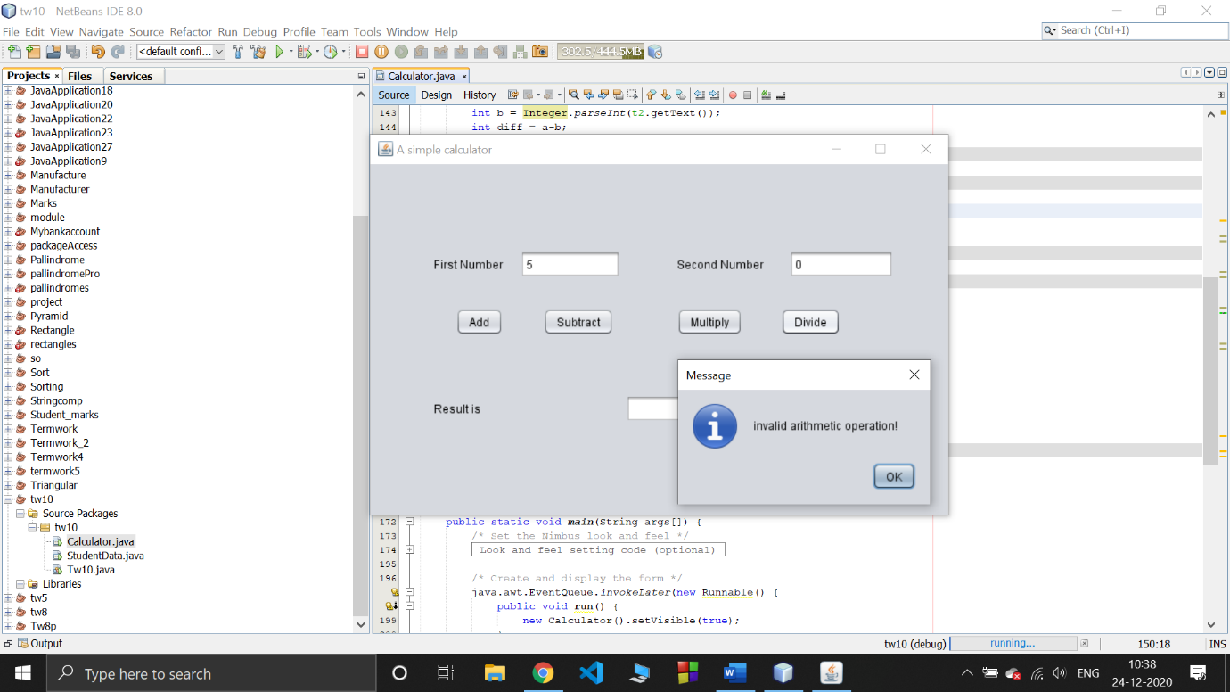

**Outcomes of the Experiment :** At the end of the laboratory sessions the students should be able to

1. Demonstrate the use of GUI in solving real-life problems.
2. Identify appropriate variables and their types.
3. Demonstrate the design of a GUI.
4. Identify the control statements needed to meet the problem requirements.

**Conclusions :**  From the given problem statement, we could identify the necessary variables of appropriate type, and looping/control statements and the necessary program logic. The program was written in NetBeans IDE(Mention the one you actually used) by creating a project. We understood the usage of the IDE in typing the code, debugging, running the program and observing the output.We came to know how to design and develop a GUI application ,we learned how to apply the business logic and controller to a JFrame. we also came to know how to apply exception handling for a particular situation when an exception occurs in the operation of a GUI application.

We also understood the use of built-in class System and its method println to display the result. The program was executed for two-three sets of input and result obtained were verified to be correct and recorded.

**Practice problem:**

Design and develop a GUI application to accepts student details as shown in the GUI below. Allow the user to add records one after the other. Once the user clicks on close, compute the average score and display the details using JTable component.

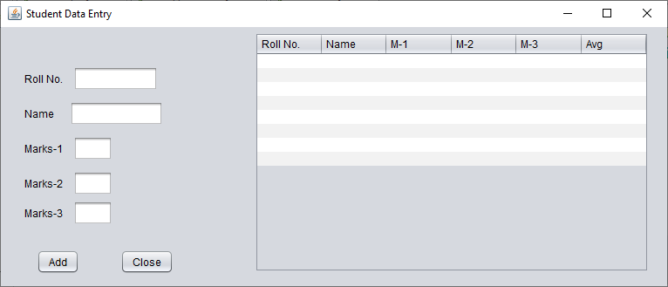

Rename close as “Summarize”

**Source code:**

package tw10;

import java.util.ArrayList;

public class StudentData extends javax.swing.JFrame {

class StudentRecord { //Inner class

String name;

int rNo, m1, m2,m3;

StudentRecord(int rNo, String name, int m1, int m2, int m3) {

this.name = name;

this.rNo = rNo;

this.m1 = m1;

this.m2 = m2;

this.m3 = m3;

}

}

ArrayList<StudentRecord> records = new ArrayList<StudentRecord>();

/**

* Creates new form StudentData

*/

public StudentData() {

initComponents();

}

/**

* This method is called from within the constructor to initialize the form.

* WARNING: Do NOT modify this code. The content of this method is always

* regenerated by the Form Editor.

*/

@SuppressWarnings("unchecked")

// <editor-fold defaultstate="collapsed" desc="Generated Code">

private void initComponents() {

jLabel1 = new javax.swing.JLabel();

jLabel2 = new javax.swing.JLabel();

jLabel3 = new javax.swing.JLabel();

jLabel4 = new javax.swing.JLabel();

jLabel5 = new javax.swing.JLabel();

jTextField1 = new javax.swing.JTextField();

jTextField2 = new javax.swing.JTextField();

jTextField3 = new javax.swing.JTextField();

jTextField4 = new javax.swing.JTextField();

jTextField5 = new javax.swing.JTextField();

jButton1 = new javax.swing.JButton();

jButton2 = new javax.swing.JButton();

jScrollPane1 = new javax.swing.JScrollPane();

jTable1 = new javax.swing.JTable();

setDefaultCloseOperation(javax.swing.WindowConstants.EXIT_ON_CLOSE);

setTitle("Student Details");

jLabel1.setText(" Roll No. :");

jLabel2.setText("Name :");

jLabel3.setText("Marks 1 :");

jLabel4.setText(" Marks 2 :");

jLabel5.setText(" Marks 3 :");

jTextField4.addActionListener(new java.awt.event.ActionListener() {

public void actionPerformed(java.awt.event.ActionEvent evt) {

jTextField4ActionPerformed(evt);

}

});

jButton1.setText("Add");

jButton1.addActionListener(new java.awt.event.ActionListener() {

public void actionPerformed(java.awt.event.ActionEvent evt) {

jButton1ActionPerformed(evt);

}

});

jButton2.setText("Summarize");

jButton2.addActionListener(new java.awt.event.ActionListener() {

public void actionPerformed(java.awt.event.ActionEvent evt) {

jButton2ActionPerformed(evt);

}

});

jTable1.setFont(new java.awt.Font("Calibri", 0, 16)); // NOI18N

jTable1.setModel(new javax.swing.table.DefaultTableModel(

new Object [][] {

{null, null, null, null, null, null},

{null, null, null, null, null, null},

{null, null, null, null, null, null},

{null, null, null, null, null, null},

{null, null, null, null, null, null},

{null, null, null, null, null, null},

{null, null, null, null, null, null},

{null, null, null, null, null, null},

{null, null, null, null, null, null},

{null, null, null, null, null, null}

},

new String [] {

"Roll No.", "Name", "M-1", "M-2", "M-3", "Average"

}

));

jScrollPane1.setViewportView(jTable1);

javax.swing.GroupLayout layout = new javax.swing.GroupLayout(getContentPane());

getContentPane().setLayout(layout);

layout.setHorizontalGroup(

layout.createParallelGroup(javax.swing.GroupLayout.Alignment.LEADING)

.addGroup(layout.createSequentialGroup()

.addGap(38, 38, 38)

.addGroup(layout.createParallelGroup(javax.swing.GroupLayout.Alignment.LEADING)

.addGroup(layout.createSequentialGroup()

.addComponent(jButton1)

.addGap(41, 41, 41)

.addComponent(jButton2))

.addGroup(layout.createSequentialGroup()

.addGroup(layout.createParallelGroup(javax.swing.GroupLayout.Alignment.TRAILING)

.addComponent(jLabel5)

.addComponent(jLabel4)

.addComponent(jLabel3)

.addComponent(jLabel2)

.addComponent(jLabel1))

.addGap(33, 33, 33)

.addGroup(layout.createParallelGroup(javax.swing.GroupLayout.Alignment.LEADING)

.addGroup(layout.createParallelGroup(javax.swing.GroupLayout.Alignment.LEADING, false)

.addComponent(jTextField2, javax.swing.GroupLayout.DEFAULT_SIZE, 76, Short.MAX_VALUE)

.addComponent(jTextField3)

.addComponent(jTextField4)

.addComponent(jTextField5))

.addComponent(jTextField1, javax.swing.GroupLayout.PREFERRED_SIZE, 93, javax.swing.GroupLayout.PREFERRED_SIZE))))

.addGap(18, 18, 18)

.addComponent(jScrollPane1, javax.swing.GroupLayout.PREFERRED_SIZE, 626, javax.swing.GroupLayout.PREFERRED_SIZE)

.addContainerGap(96, Short.MAX_VALUE))

);

layout.setVerticalGroup(

layout.createParallelGroup(javax.swing.GroupLayout.Alignment.LEADING)

.addGroup(layout.createSequentialGroup()

.addGap(47, 47, 47)

.addGroup(layout.createParallelGroup(javax.swing.GroupLayout.Alignment.LEADING)

.addComponent(jLabel1)

.addComponent(jTextField1, javax.swing.GroupLayout.PREFERRED_SIZE, javax.swing.GroupLayout.DEFAULT_SIZE, javax.swing.GroupLayout.PREFERRED_SIZE))

.addPreferredGap(javax.swing.LayoutStyle.ComponentPlacement.RELATED)

.addGroup(layout.createParallelGroup(javax.swing.GroupLayout.Alignment.LEADING)

.addComponent(jLabel2)

.addComponent(jTextField2, javax.swing.GroupLayout.PREFERRED_SIZE, javax.swing.GroupLayout.DEFAULT_SIZE, javax.swing.GroupLayout.PREFERRED_SIZE))

.addPreferredGap(javax.swing.LayoutStyle.ComponentPlacement.RELATED)

.addGroup(layout.createParallelGroup(javax.swing.GroupLayout.Alignment.BASELINE)

.addComponent(jLabel3)

.addComponent(jTextField3, javax.swing.GroupLayout.PREFERRED_SIZE, javax.swing.GroupLayout.DEFAULT_SIZE, javax.swing.GroupLayout.PREFERRED_SIZE))

.addGap(18, 18, 18)

.addGroup(layout.createParallelGroup(javax.swing.GroupLayout.Alignment.BASELINE)

.addComponent(jLabel4)

.addComponent(jTextField4, javax.swing.GroupLayout.PREFERRED_SIZE, javax.swing.GroupLayout.DEFAULT_SIZE, javax.swing.GroupLayout.PREFERRED_SIZE))

.addPreferredGap(javax.swing.LayoutStyle.ComponentPlacement.UNRELATED)

.addGroup(layout.createParallelGroup(javax.swing.GroupLayout.Alignment.BASELINE)

.addComponent(jLabel5)

.addComponent(jTextField5, javax.swing.GroupLayout.PREFERRED_SIZE, javax.swing.GroupLayout.DEFAULT_SIZE, javax.swing.GroupLayout.PREFERRED_SIZE))

.addGap(99, 99, 99)

.addGroup(layout.createParallelGroup(javax.swing.GroupLayout.Alignment.BASELINE)

.addComponent(jButton1)

.addComponent(jButton2))

.addContainerGap(javax.swing.GroupLayout.DEFAULT_SIZE, Short.MAX_VALUE))

.addGroup(layout.createSequentialGroup()

.addComponent(jScrollPane1, javax.swing.GroupLayout.PREFERRED_SIZE, javax.swing.GroupLayout.DEFAULT_SIZE, javax.swing.GroupLayout.PREFERRED_SIZE)

.addGap(0, 103, Short.MAX_VALUE))

);

pack();

}// </editor-fold>

private void jTextField4ActionPerformed(java.awt.event.ActionEvent evt) {

// TODO add your handling code here:

}

private void jButton2ActionPerformed(java.awt.event.ActionEvent evt) {

int rowCount = 0;

for(StudentRecord s : records) {

jTable1.setValueAt(s.rNo, rowCount, 0);

jTable1.setValueAt(s.name, rowCount, 1);

jTable1.setValueAt(s.m1, rowCount, 2);

jTable1.setValueAt(s.m2, rowCount, 3);

jTable1.setValueAt(s.m3, rowCount, 4);

float avg = (s.m1+s.m2+s.m3) / 3.0f;

jTable1.setValueAt(String.format("%.2f",avg), rowCount, 5);

rowCount++;

}

}

private void jButton1ActionPerformed(java.awt.event.ActionEvent evt) {

StudentRecord s1 = new StudentRecord(Integer.parseInt(jTextField1.getText()),

jTextField2.getText(), Integer.parseInt(jTextField3.getText()),

Integer.parseInt(jTextField4.getText()),

Integer.parseInt(jTextField5.getText()));

records.add(s1);

jTextField1.setText("");

jTextField2.setText("");

jTextField3.setText("");

jTextField4.setText("");

jTextField5.setText("");

}

/**

* @param args the command line arguments

*/

public static void main(String args[]) {

/* Set the Nimbus look and feel */

//<editor-fold defaultstate="collapsed" desc=" Look and feel setting code (optional) ">

/* If Nimbus (introduced in Java SE 6) is not available, stay with the default look and feel.

* For details see http://download.oracle.com/javase/tutorial/uiswing/lookandfeel/plaf.html

*/

try {

for (javax.swing.UIManager.LookAndFeelInfo info : javax.swing.UIManager.getInstalledLookAndFeels()) {

if ("Nimbus".equals(info.getName())) {

javax.swing.UIManager.setLookAndFeel(info.getClassName());

break;

}

}

} catch (ClassNotFoundException ex) {

java.util.logging.Logger.getLogger(StudentData.class.getName()).log(java.util.logging.Level.SEVERE, null, ex);

} catch (InstantiationException ex) {

java.util.logging.Logger.getLogger(StudentData.class.getName()).log(java.util.logging.Level.SEVERE, null, ex);

}

catch (IllegalAccessException ex) {

java.util.logging.Logger.getLogger(StudentData.class.getName()).log(java.util.logging.Level.SEVERE, null, ex);

}

catch (javax.swing.UnsupportedLookAndFeelException ex) {

java.util.logging.Logger.getLogger(StudentData.class.getName()).log(java.util.logging.Level.SEVERE, null, ex);

}

//</editor-fold>

/* Create and display the form */

java.awt.EventQueue.invokeLater(new Runnable() {

public void run() {

new StudentData().setVisible(true);

}

});

}

// Variables declaration - do not modify

private javax.swing.JButton jButton1;

private javax.swing.JButton jButton2;

private javax.swing.JLabel jLabel1;

private javax.swing.JLabel jLabel2;

private javax.swing.JLabel jLabel3;

private javax.swing.JLabel jLabel4;

private javax.swing.JLabel jLabel5;

private javax.swing.JScrollPane jScrollPane1;

private javax.swing.JTable jTable1;

private javax.swing.JTextField jTextField1;

private javax.swing.JTextField jTextField2;

private javax.swing.JTextField jTextField3;

private javax.swing.JTextField jTextField4;

private javax.swing.JTextField jTextField5;

// End of variables declaration

}

**Output :**

